**VS Code**  
👉 This is the software where you'll write code.

**Java JDK (Java 21)**  
👉 Java Development Kit is needed to run Java programs.

**Maven**  
👉 A tool that helps you build and run Java projects easily.

1. **Download & Install**:
   * [VS Code](https://code.visualstudio.com/) (<https://code.visualstudio.com/>)
   * [Java JDK](https://adoptium.net/) (<https://www.oracle.com/in/java/technologies/downloads/#jdk21-windows>)
   * [Maven](https://maven.apache.org/download.cgi) (<https://maven.apache.org/download.cgi>)
2. **Install VS Code Extensions**:  
   In VS Code → Extensions tab:
   * ✅ Java Extension Pack (by Microsoft)
   * ✅ Spring Boot Extension Pack (by Pivotal or VMWare)
3. **Create a Spring Boot Project Easily**:
   * Use the Spring Initializr (built into VS Code):

Ctrl+Shift+P → Spring Initializr: Generate a Maven Project

* + Choose:
    - Group: com.example
    - Artifact: helloservice
    - Dependencies: Spring Web

1. You can see default Java file is created in VScode
2. **Edit code and run** using:

VS Code terminal: mvn spring-boot:run



Or click the green **Run** button

In browser

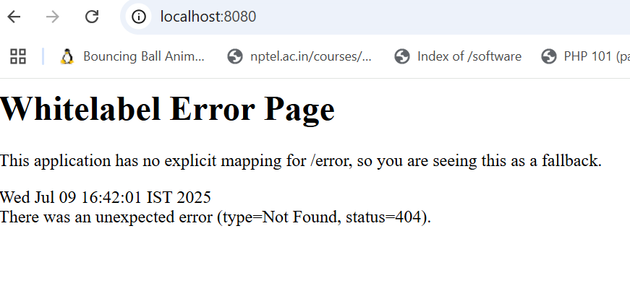

1. Access Your REST endpoint via Controller class or cURL

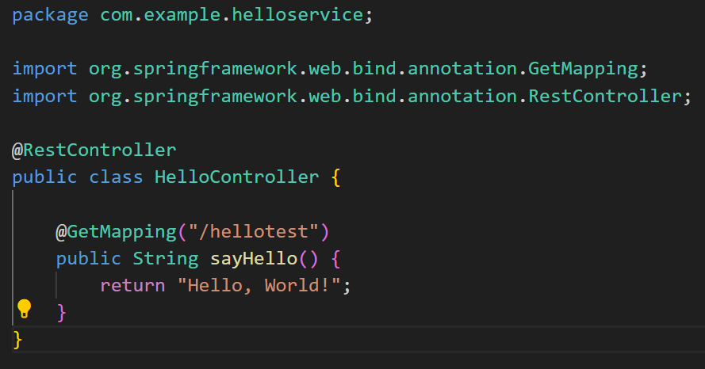

And save this file in the same folder where the application file resides

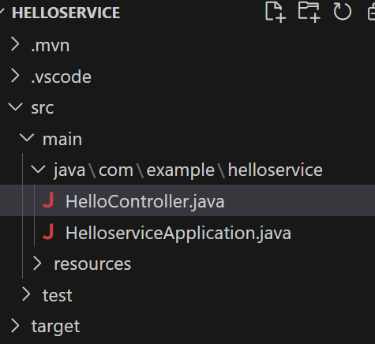

**To run the application after placing HelloController.java file in the folder**

* Firstly stop currently running HelloserviceApplication.java
  + Ctrl C
* Then re-run the application and controller code using the same command
  + mvn spring-boot:run
* Test whether the controller is communicating by opening a browser and type the following and you got the result “Hello, World”
  + <http://localhost:8080/hellotest>
* Or using cURL
  + curl http://localhost:8080/hellotest